VSCode-Qmio connection guide

Windows:

1- Download the VSCode installator from: https://code.visualstudio.com/
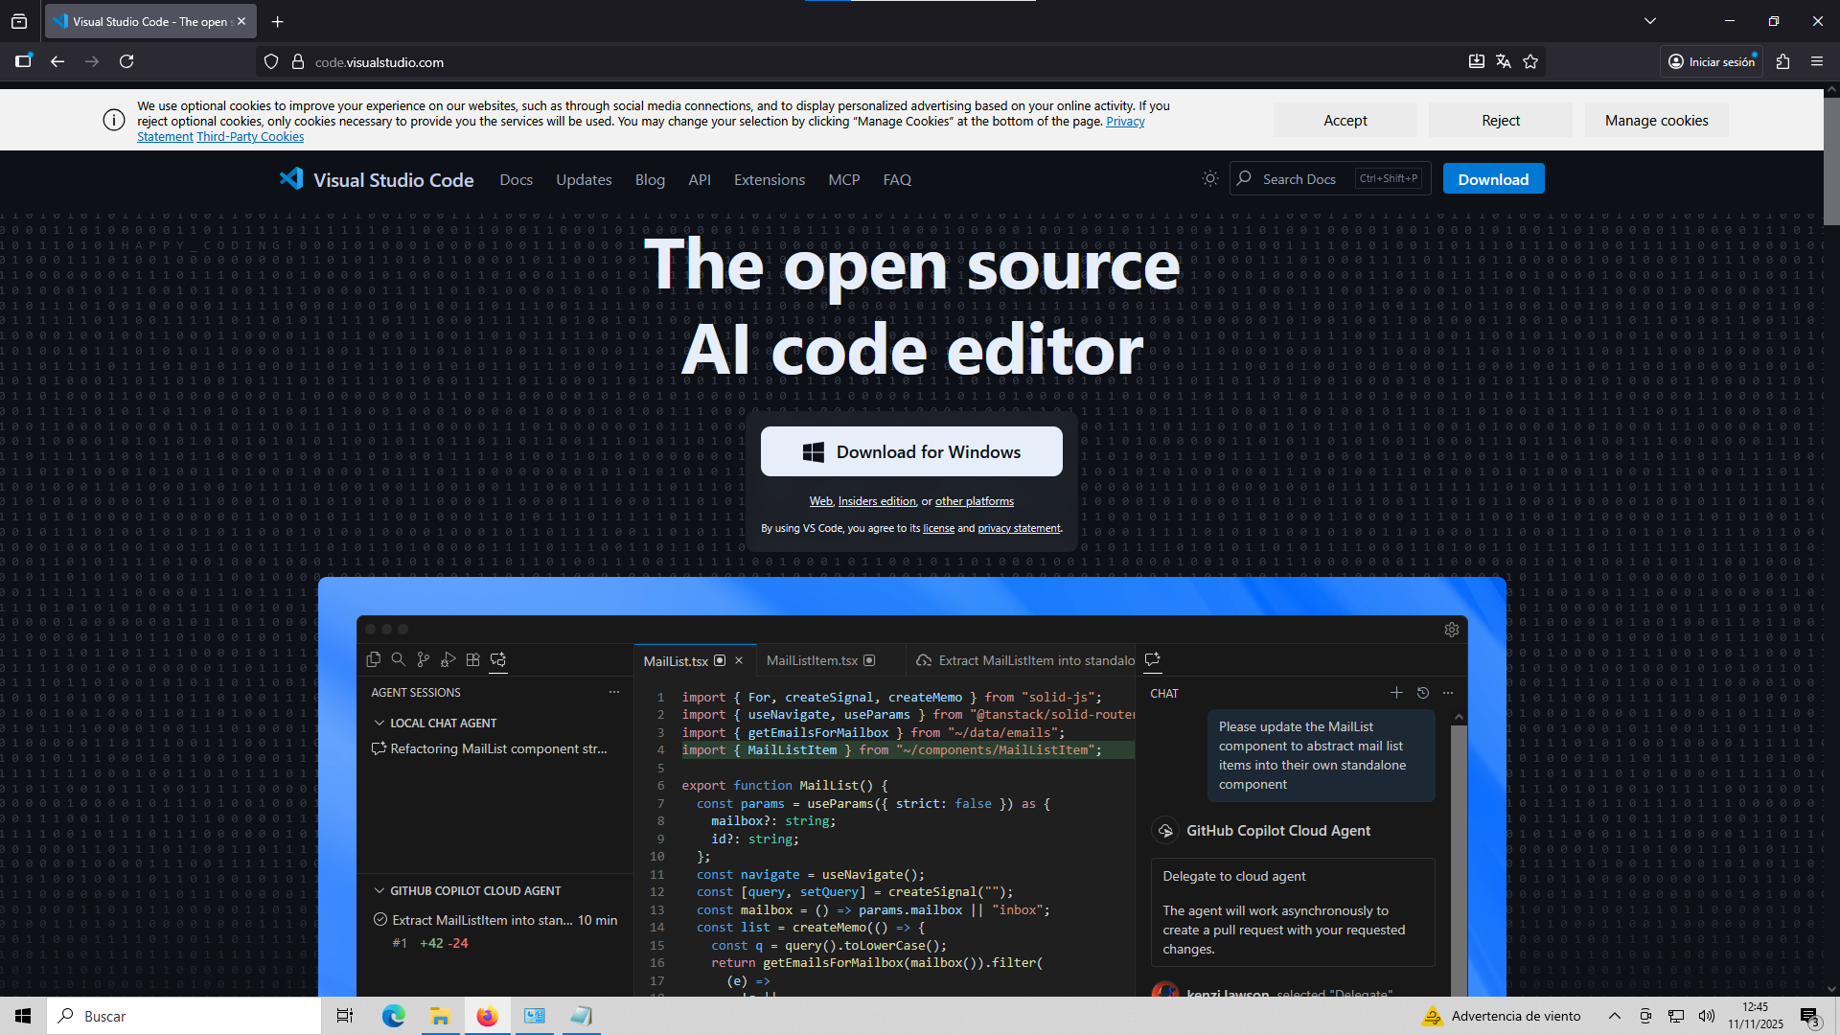
2- Execute the installator (.exe) and click accept to everything.

3- Once it’s installed, open VSCode and go to extensions.

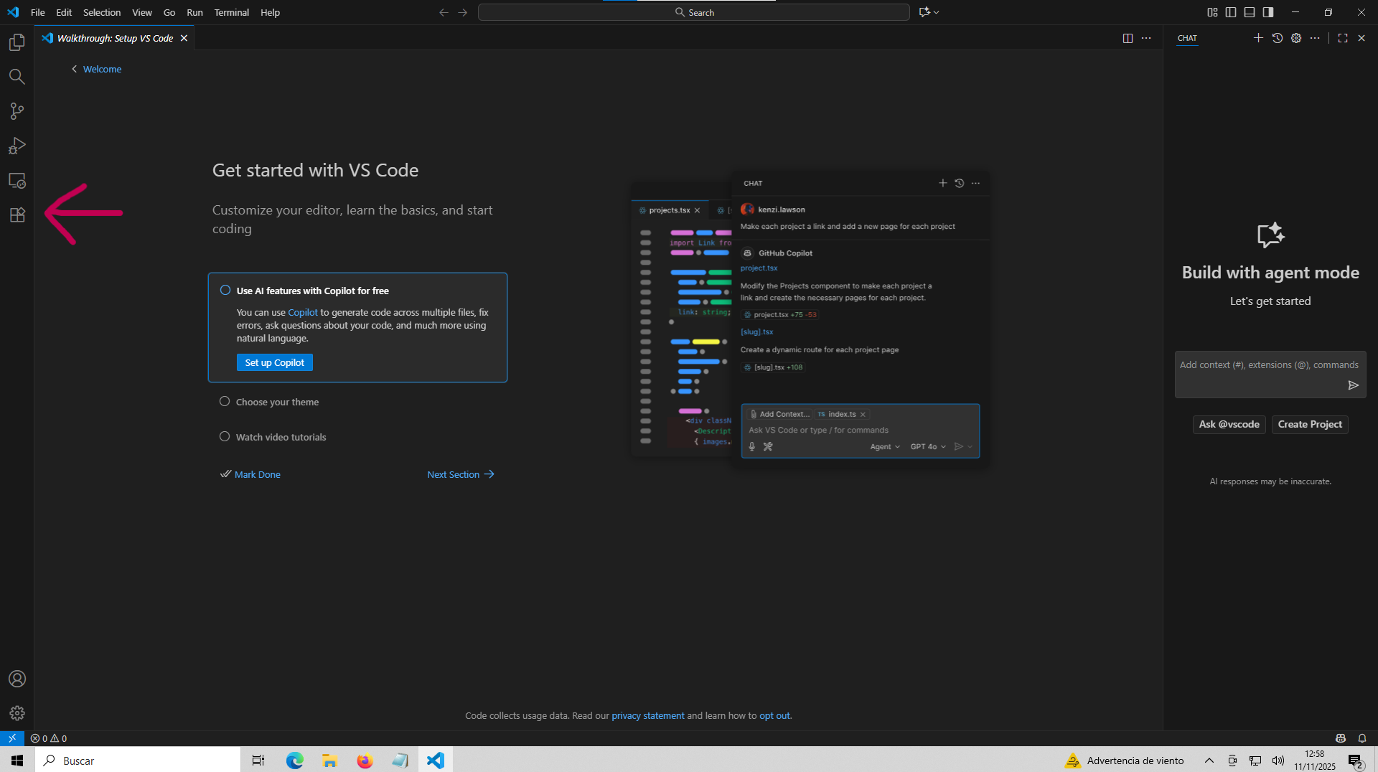
4- Install the official Microsoft extension: Remote-SSH

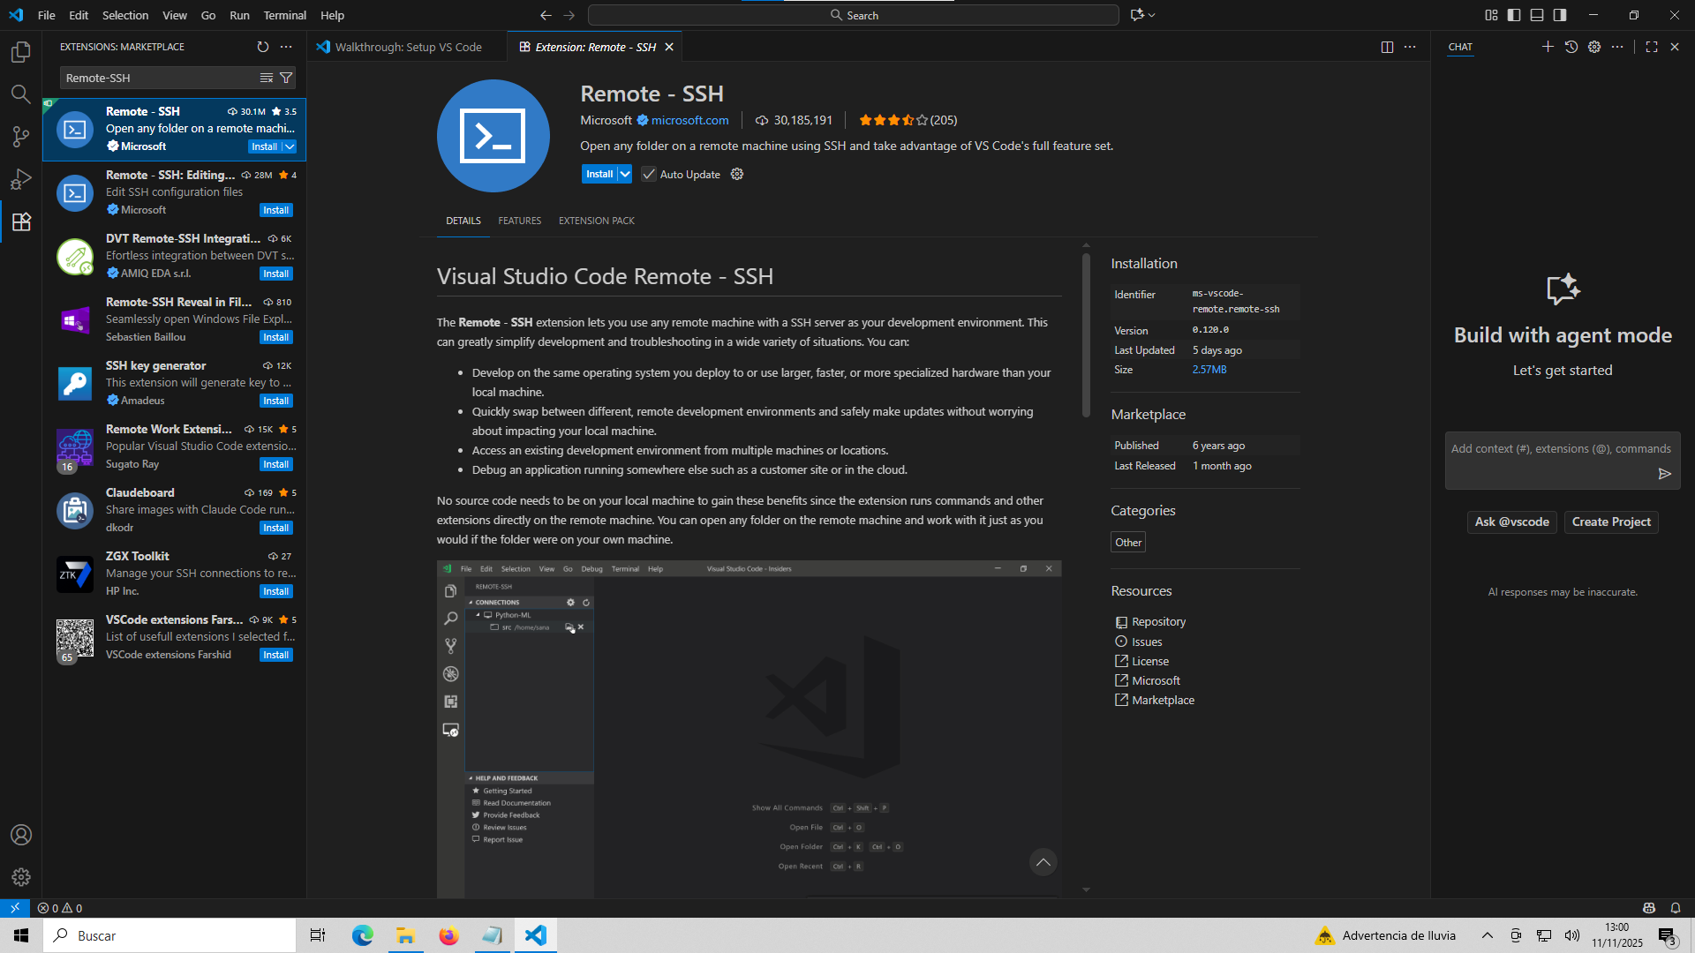
5- Now you have to create a ssh key pair to connect to Qmio. First press Windows + r and you will see the following window:

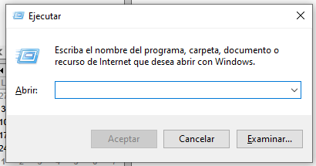

6- Now type cmd and press Enter to open the command terminal:

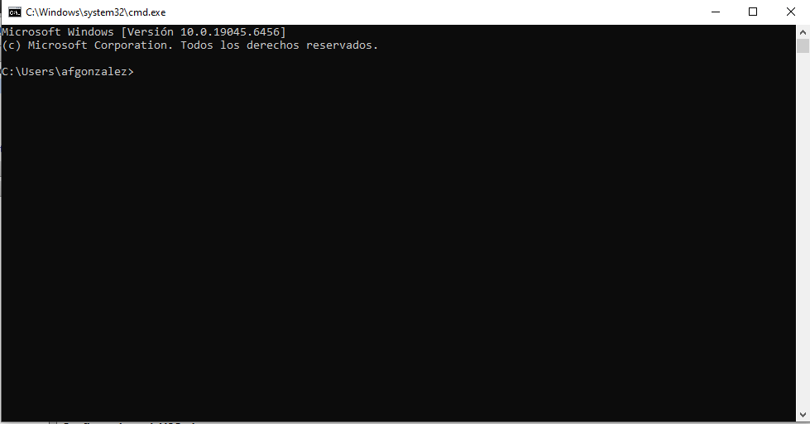
7- Then, to go to the .ssh folder, type:

cd .ssh

and press Enter

In case the .ssh folder does not exist, create it at:
C:\Users\<your_local_User>\ ,then you will have to close the terminal and open it again to navigate to the folder.
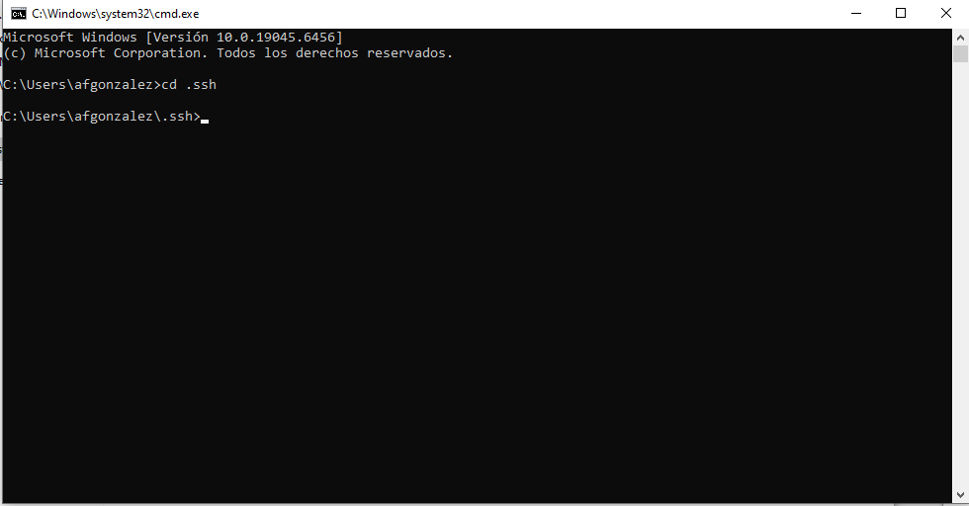
8- Then, to create the keys, type:

ssh-keygen -t rsa -b 4096

and press Enter

9- You will be asked to write the name of a file in which they key will be written. Write: key

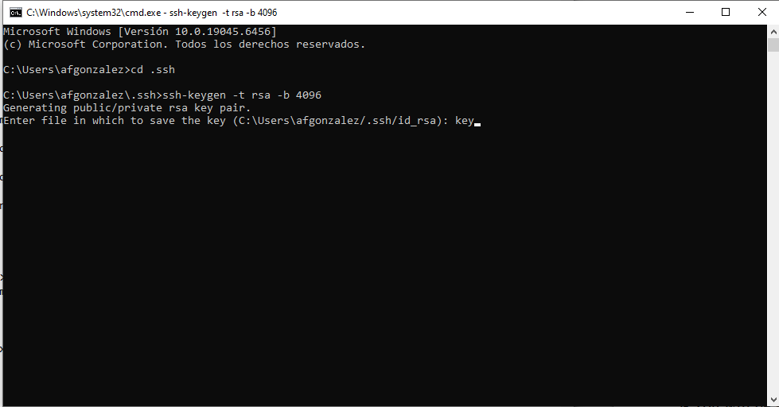
10- You will be asked for a password for the key file but it’s optional, just press Enter to skip it. The key files will be created inside .ssh

11- Now, inside the .ssh folder you will have to create an extensionless file called config with the following content:

Host Qmio
HostName qmio.cesga.es
User <Qmio_UserName>
IdentityFile C:\Users\<Your_PC_UserName>\.ssh\key
MACs hmac-sha2-512

**To create an extensionless file: open notepad, write the text and then go to: save file as…
Select “all files” and write the name of the file between double quotes : “config”

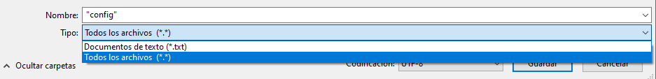

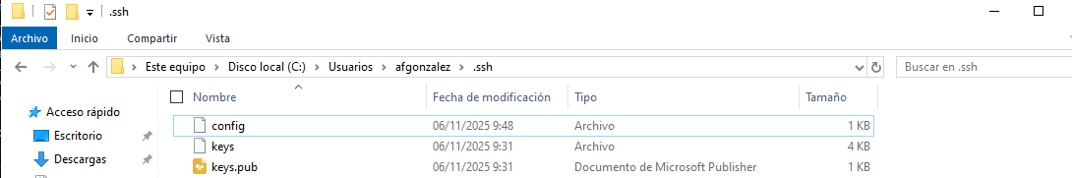
12- Now everything is ready for the connection, open VSCode and click Connect to

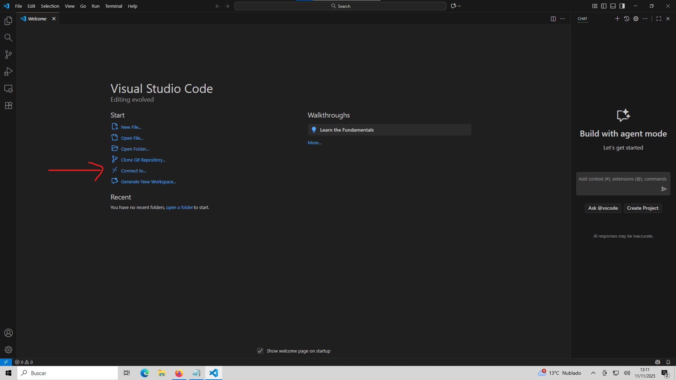

13- Click in Connect to Host

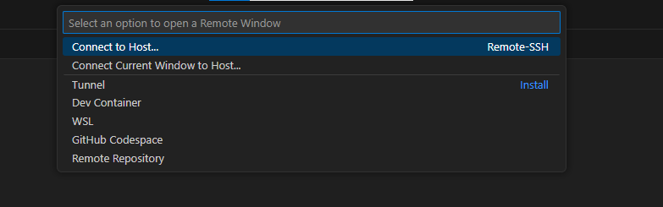
14- Select Qmio

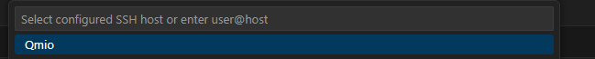
14- Select Linux and then write your Qmio password in the box

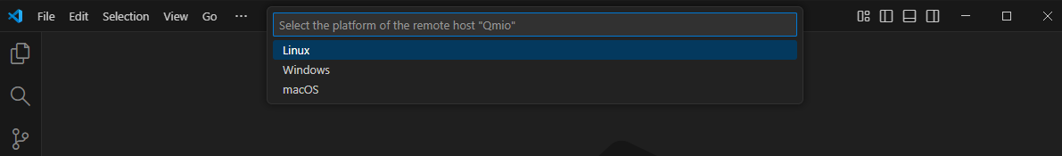
15- Finally, to open the Qmio terminal, click in this icon:

